**Development of the Front-End Interface for EDU.AI – An AI-Powered Education Platform**  
**Author: Jabbarova Gulsevar**

**Abstract**

EDU.AI is an AI-powered platform we’re building to make studying easier and smarter. The main idea is to help students deal with long, complex texts by summarizing them into something more manageable. But that’s not all — it also creates flashcards and quizzes from the content, so learners can review and test themselves without spending hours making notes manually.

In our first week, my teammate and I focused on designing and building the front-end. We started by sketching out how we wanted the platform to look and feel, and then we worked together to bring those ideas to life. I handled most of the implementation using **Next.js**, **Tailwind CSS**, and **Framer Motion** to create a clean, responsive design with smooth animations.

So far, we’ve finished the landing page and built almost all of the dashboard. It’s fully functional and looks great on different screen sizes, but we still have a few small things to polish. We kept the design flexible so we can easily connect it with AI features and backend logic later on.

Overall, it’s been a really productive start. We’re proud of how much we’ve built in just a week, and we’re excited to keep improving EDU.AI and turning it into a tool that can actually help people learn better and faster.

**Introduction**

In today’s world, students are constantly surrounded by endless amounts of information such as long textbook chapters, research articles, lecture notes, and more. While all this content is valuable, it can be overwhelming and time-consuming to study effectively. That’s where the idea for EDU.AI came from. We wanted to create a platform that helps learners understand more in less time without losing the important details.

EDU.AI is designed to make learning smarter, not harder. The platform uses artificial intelligence to summarize long texts, automatically generate flashcards, and create quizzes based on the key points in the material. Our goal is to help students focus on what matters most: learning, reviewing, and testing themselves, instead of spending hours trying to organize or rewrite notes.

For the first week of this project, our main focus was the user interface design and front-end development. We wanted to create a space that is clean, easy to navigate, and feels intuitive to use. My teammate and I worked together on the design concept, making sure the layout would support all the upcoming features like summary display, interactive flashcards, and quizzes. After finalizing the design, I began building the components using Next.js for the framework, Tailwind CSS for styling, and Framer Motion for animations.

This introduction outlines why we are building EDU.AI, what problem it solves, and how we approached the first stage of development. Our long-term vision is to make this platform a helpful companion for any student, whether they are preparing for exams, reviewing lectures, or learning something new on their own.

**Methods**

To start building EDU.AI, we focused on creating a front end that would be both functional and easy to use. Since the first impression of any platform comes from its interface, we wanted to make sure our design would be clean, modern, and welcoming to users of all backgrounds. We began by brainstorming and sketching ideas for how the landing page and dashboard should look and function.

My teammate and I worked closely during the design phase. We shared ideas about layout, user flow, and how each feature such as summaries, flashcards, and quizzes should appear on the platform. Once we had a clear plan, I began developing the interface using a set of modern web tools.

We chose Next.js as our main framework because it is fast, efficient, and suitable for building responsive applications. For styling, we used Tailwind CSS, which allowed us to quickly build and adjust layouts using utility classes. To make the interface feel smooth and interactive, we included animations using Framer Motion, a powerful library for React animations.

During development, we focused on writing clean and reusable components. We tested everything on different screen sizes to make sure the platform would work well on mobile devices as well as larger screens. To stay organized and track our progress, we used GitHub for version control and team collaboration.

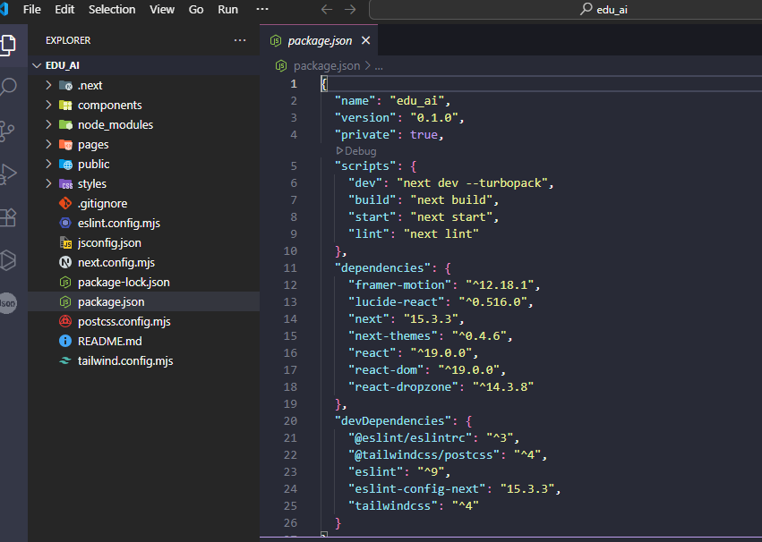

**Results**

By the end of the first week, we made significant progress on the front-end development of EDU.AI. The landing page is fully functional and styled, with a clean layout, responsive design, and smooth animations that make the platform feel modern and interactive. The layout includes all the core sections we planned, such as the project introduction, features overview, and call-to-action buttons for user engagement.

The dashboard, which is the main working area of the platform, is almost complete. It includes the basic structure needed to display summaries, flashcards, and quizzes. While a few minor finishing touches are still needed, the core design and layout are already in place. This includes the sidebar, navigation, content areas, and placeholder sections for future AI-generated content.

All components were tested on different devices to ensure they respond well to various screen sizes. The interface looks consistent and performs smoothly across desktop, tablet, and mobile views.

Another key result from this week is the flexible and reusable code structure. We designed our components in a way that allows us to easily expand and connect them with backend logic in the upcoming phases. This will save time and effort as we move forward into integrating the AI features that power text summarization, flashcard generation, and quizzes.

Overall, our work this week has laid a strong foundation for the entire platform. We are now in a great position to move into the next stage of development, where users will be able to interact with real data and benefit from the AI-powered learning tools that make EDU.AI unique.

